Evidence-to-Decision tool

What's this tool for?
The Evidence-to-Decision tool has been co-designed between the Conservation Evidence group and practitioners from several organisations to help guide practitioners through the process of making an evidence-informed decision. The tool is structured to help you consider and combine several forms of evidence (e.g., scientific evidence, tacit knowledge, values, costs) to reach a transparent decision, documenting each stage of the process so that the logic and reasoning behind decisions can be open and traceable.
The tool is structured using three steps: 1.) Define the Decision Context (i.e., What is the problem you want to solve?); 2.) Gather Evidence (i.e., What actions are likely to be the most effective to address my problem in my local context?); 3.) Make an Evidence-Informed Decision (i.e., What are the next steps? Which actions will be implemented based on the evidence you have assessed?). The diagram below lays out the detailed steps that this tool will guide you through.
This tool is best suited for use by individual landowners, reserve managers, and small NGOs working on specific projects to come to an evidence-informed decision for a specific problem. The tool was designed to streamline an evidence-informed decision-making process with limited time and resources. The tool can also be used to begin thinking about how to tackle major decisions, laying the foundation for a more in-depth decision-making process using other tools and frameworks (e.g., Structured Decision-Making, Multi-Criteria Decision Analysis, or Theory of Change etc.).
To begin using the tool, click on 1. Define the Decision Context. Throughout this tool you will be prompted to enter information which will be compiled and documented in a report which you will be able to download in the final step. (If you wish to see an example of what the tool produces, please go to tab 3. Make an Evidence-Informed Decision and scroll to the bottom). Download the E2D Tool Guide for extra guidance. Tips will also appear if you hover over the bold text directly above text boxes in the tool.
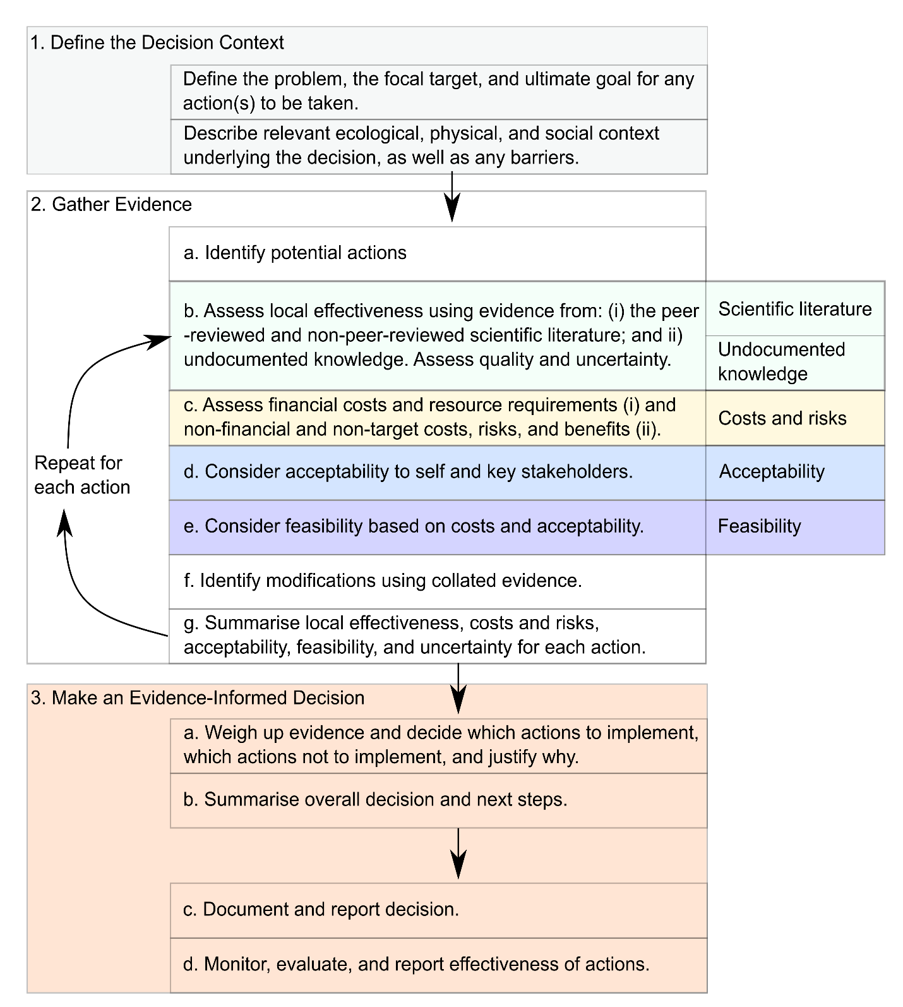
This tool was created by Dr Alec Christie, University of Cambridge. Thank you to all the practitioners who took part in the co-design of this tool, including (in no particular order): Steve Weeks, Alison Ruyter, Rory Harding, and Paul Tinsley-Marshall from the Kent Wildlife Trust; Tom McPherson from Ingleby Farms (also for giving feedback on the manuscript); the Woodland Trust; Peoples’ Trust for Endangered Species; Jon Flanders and Winifred Frick at Bat Conservation International; David O’Brien at NatureScot; Kathy Wormald at Froglife; the Medway Valley Countryside Partnership; Sheffield & Rotherham Wildlife Trust; Bedfordshire, Buckinghamshire, and Oxfordshire Wildlife Trust; Catherine McNicol at Gloucestershire Wildlife Trust. Thanks also to Harriet Downey, Matthew Grainger, Thomas White, Michael Winter, and William Sutherland for their help in producing the tool.

Evidence-to-Decision tool
DD-MM-YYYY
Name of decision-maker | Name of decision-maker's organisation
[Your name] | [Your organisation]

1. Define the Decision Context

What is the problem and desired outcomes? What is the relevant ecological, physical, and social context underlying the decision?
It is important to carefully define and detail the context surrounding the decision to be made. This includes the problem (or direct threat) being tackled, the location the decision affects, the ultimate goal you want to achieve (i.e., the desired outcomes), the focal target of any action (i.e., the species, habitat, or group), and any other relevant contextual information (e.g., socio-ecological factors, constraints on decision-making.
What is the problem?

Location

What is the ultimate goal?

What is the focal target?

What is the relevant ecological, physical, and social context underlying the decision? What constraints are there on your decision making?

2. Gather Evidence
Which action(s) could be taken to address the problem, regardless of their cost, acceptability, or feasibility?
You are now asked to gather evidence for and against the implementation of different action(s) to address the Decision Context defined in the previous tab. We suggest you start by identifying potential management actions to address your problem (2.a), and then consider diverse forms of evidence on the effectiveness, costs, acceptability, and feasibility of each action by using the menu on the right (this will bring up more content below).
Brainstorm and note as many potential actions as you can to address the decision or problem you are considering - for possible ways to do this, see the E2D Tool Guide. Don't forget to look into the literature and search websites like Conservation Evidence to inform your list of actions. Make sure to include actions regardless of their acceptability, feasibility, or costs at this stage. These actions can be ruled out later if they are too expensive, unfeasible, or unacceptable. Once you have entered your list of potential actions below, add them one at a time using the right-hand menu (this will generate content below for you to fill in for each one).

2.A. Potential actions

- …
- …
- …

Copy and paste the text below (2.B-G.) for each of the potential actions you identified above.

2.B-G. Action 1 [Enter the name of the potential action]

Describe action | Focus of action

2.B. Assess desirable and undesirable effects on the focal target and uncertainty
What do different types of evidence tell us about the desirable and undesirable effects of each action on the focal target? How certain are we of the credibility of this evidence?
In this section you are asked to assess the likely effectiveness of this action within your local decision context (specifically regarding your focal target - there is space later in the tool to assess cost-effectiveness, side-effects, and wider impacts of actions).

2.B.i. Scientific literature
How locally effective is this action likely to be based on evidence from the scientific literature? What is the overall certainty (reliability) of this evidence?
Evidence sources considered

Detailed assessment of evidence

Summarise assessment of evidence

Score effectiveness based on scientific literature and undocumented knowledge
Harmful Ineffective Weakly effective Moderately effective Highly effective
Trade-off between benefits and harms Unsure
Score certainty in this score
Very low Low Moderate High Unsure

2.B.ii. Practitioners’ own data, written experience, and monitoring
How locally effective is this action likely to be based on your own monitoring data or notes? What is the overall certainty (reliability) of this evidence?
This section includes any evidence you can provide from your own data, monitoring, or written experience (e.g., logbooks or notebooks) on the likely effectiveness of each action. This is separate to the grey or non-peer-reviewed literature as this evidence is usually internal (i.e., collected by the decision-maker or their organisation) rather than external, and is documented or recorded in the form of physical data or written observations – hence the distinction from undocumented knowledge (see E2D Tool Guide for more information).
Own data, written experience, and monitoring

Score effectiveness based on own data, written experience, and monitoring
Harmful Ineffective Weakly effective Moderately effective Highly effective
Trade-off between benefits and harms Unsure
Score certainty in this score
Very low Low Moderate High Unsure

2.B.iii. Undocumented knowledge
How locally effective is this action likely to be based on you and your stakeholders’ knowledge? What is the overall certainty (reliability) of this knowledge?
We use the term ‘undocumented knowledge’ for the purposes of this tool to specify information that is not published or written down, which typically includes a knowledge holder’s intuition, experience, wisdom, and values (also known as ‘tacit’ knowledge). For example, have you attempted this action yourself in the past? Are there any descriptive notes or reports from your organisation that can help? Do local stakeholders have any information or local knowledge you can integrate? Try to critically assess the uncertainty associated with this knowledge (i.e., How much expertise does the person offering the local knowledge have? What biases are they prone to suffer from and how does this affect the trustworthiness of their evidence?). See the E2D Tool Guide for more guidance.
Undocumented knowledge

Score effectiveness based on undocumented knowledge
Harmful Ineffective Weakly effective Moderately effective Highly effective
Trade-off between benefits and harms Unsure
Score certainty in this score
Very low Low Moderate High Unsure

2.C. Assess costs and risks

2.C.i. Assess financial and resource-based cost-effectiveness
How much does the action cost financially and what are its resource requirements? What is the overall certainty (reliability) of these costs?
Resource requirements and financial costs form the core of assessing the cost-effectiveness of each action. These can be broadly defined as the resources and finances required to implement a conservation action.
It is good practice to ensure estimates of cost include the direct costs of implementation (including labour, time, consumables, overheads and equipment) and possibly changes in future finances predicted as a result of the action including opportunity costs (i.e., loss of income) and costs of future management and monitoring. Any cost benefits, for example solving a problem (e.g., removing an invasive species) and not having to pay recurrent costs, can also be considered. Cost information can be collated from literature, guidance and accounts but also from experience and knowledge. It is useful to ensure that costs for each action are considered on the same scale so that they are comparable - for example, the cost per unit area or per unit of effort.
Financial and resource based cost-effectiveness

Score cost-effectiveness based on financial and resource-based costs
Very low Low Moderate High Unsure
Score certainty in this score
Very low Low Moderate High Unsure

2.C.ii. Assess the non-financial costs, risks, and wider benefits for non-target species, habitats, and stakeholders
What are the wider non-financial costs, risks, and benefits of implementing this action?
Non-financial costs and benefits are the wider undesirable and desirable effects of the action on species, habitats, and stakeholders that are not the focus of the action. Costs may include socio-cultural considerations if the action did not target socio-cultural outcomes; for example, considering whether using pesticides, excluding access, or removing invasive species may have 'reputational costs' to the practitioner, stakeholders, or their organisations (i.e., has a negative impact on how they are perceived by the general public or other groups).
Non-financial, non-target costs and risks

Wider benefits

Score balance between non-financial, non-target costs, risks, and wider benefits
Costs/risks far greater Costs/risks slightly greater Trade-off between costs/risks and benefits Benefits slightly greater Benefits far greater Unsure

Score certainty in this score
Very low Low Moderate High Unsure

2.D. Assess acceptability
Are the effects of implementing this action acceptable to all the key stakeholders? Are there sociocultural barriers to implementing this action?
Carefully consider whether it is acceptable to implement this action - do the outcomes of this action align to the values held by yourself and key stakeholders? Before you decide, it may be helpful to identify the major relevant values held by yourself and key stakeholders. It is outside the scope of this tool to elicit these values directly from key stakeholders, so we would suggest that the user and organisation gathers in this information (using suitable methods already used by organisations, e.g., formal consultations, focus groups etc.) and summarises this here.
Acceptability

Score Acceptability
Very low Low Moderate High Unsure
Score certainty in this score
Very low Low Moderate High Unsure

2.E. Assess feasibility
Can this action be successfully accomplished and properly implemented?
Assessing the feasibility of actions involves considering both the costs and acceptability of the action to key stakeholders. For example, resistance to the action from key stakeholders will be important if cooperation is a part key of its success and so if the action is likely to be unacceptable to key stakeholders, its feasibility is also likely to be low. Considering access or availability of equipment, resources, or staff to undertake a management action will also be important; for example, an action may not be feasible if the equipment needed cannot be moved to the location of interest. Feasibility may also involve considering the costs associated with each action, such as whether the action exceeds a strict budget or will be able to be approved by any stakeholders that must agree to its implementation.
Carefully consider whether it is feasible to implement this action.
Feasibility

Score Feasibility
Very low Low Moderate High Unsure
Score certainty in this score
Very low Low Moderate High Unsure

2.F. Consider modifications
How can the action be modified based on the previous evidence gathered?
By assessing the evidence from different sources on effectiveness, costs, acceptability, and feasibility of the action, modifications can be considered that might improve it. For example, there may be strong evidence from the scientific literature to suggest that creating certain habitats for great crested newts and white-faced darters will be beneficial, but a practitioner's explicit or tacit local knowledge also suggests that these species have slightly different habitat preferences in this region, and so a modification to this action may be necessary for it to be locally effective. Or an action such as an education campaign may not be acceptable to a key stakeholder if it is designed in a certain way, so modifications are necessary to ensure the action is acceptable. A structural action may also be too expensive to implement using certain materials and to be more cost-effective and ultimately more feasible, the action must be modified by using cheaper materials.
Consider effectiveness of modifications

Score potential of modifications to improve action
Very low Low Moderate High Unsure
Score certainty in this score
Very low Low Moderate High Unsure

2.G. Summarise the evidence gathered
How likely is this action to be locally effective based on all the evidence and information you have gathered? What is the overall level of uncertainty associated with these conclusions?
Once the previous steps have been considered, it may be useful to summarise the likely local effectiveness of each action (whether modified or not), and the important costs, acceptability, and feasibility considerations that come with them. This draws together all the evidence previously gathered so that an evidence-informed decision can be made in the next step, considering the relative advantages and disadvantages of each action alongside each other. Uncertainty is also important to consider here, in particular to understand whether the evidence that has been gathered is sufficient in its reliability and relevance to make robust conclusions. It is also important to consider if there is conflicting evidence from different sources - for example, how much trust can be placed in the evidence drawn from the scientific literature versus evidence drawn from local knowledge?
Summarise evidence for and against implementation

3. Make an Evidence-Informed Decision

Summary assessment table for each action
Table legend. Colour code by certainty: White = Very low certainty or unsure. Pale yellow = Low certainty. Yellow = Moderate certainty. Gold = High certainty.
Action | Local effectiveness | Cost-effectiveness | Balance between non-target costs/risks and wider benefits | Acceptability | Feasibility
…
…
…

3.A. Weigh up the evidence for and against different actions
Reflecting on the problem you face and the evidence and information you have gathered, what is your decision and why?
Using the accumulated evidence, the relative advantages and disadvantages of each modified action can be compared and related back to the original decision or problem being considered (in Step 1. Define the Decision Context). This involves weighing up how locally effective, cost-effective, acceptable, and feasible each action is and whether its implementation is justified.
We would suggest that users could prioritise actions based on their place in the Mitigation and Conservation Hierarchy (see here). For example, we would recommend tat actions that avoid and minimize threats should be prioritised, before restoration and compensatory measures are considered.
Which action(s) if any are the best ones to implement to achieve the ultimate goal(s) you defined at the beginning? Name and justify your choices.

Which action(s), if any, should not be implemented? Name and justify your choices.

3.B. Justify overall decision and next steps
What is the overall decision, what are the next steps, and why?
Summarise your overall decision and the next steps you will take. This could be implementing these actions, pausing to make a more detailed assessment, gather more evidence, or decide to do nothing.
Decision and next steps

3.C. Document and report decision
We suggest you could save this document for future use and consider creating a ‘Decisions Library’, enabling the dissemination and sharing of information on how past decisions were made, as well as to enable you to revisit and reassess decisions based on new evidence or for new projects. This lends itself to the iterative concept of Adaptive Management, whereby the tool could be revisited based on the success of implemented actions, and provides a much-needed link between Adaptive Management and Evidence-Based Conservation.

Copyright

The Evidence-to-Decision Tool by Alec P. Christie and Conservation Evidence is licensed under a Creative Commons Attribution-ShareAlike 4.0 International License. Based on a work at https://github.com/alecchristie888/shiny-server.
This means you need to appropriately attribute us and then share using the same license, but do look at the link to Creative Commons to read the details.

